Alcohol-Associated Bowel Disease (ABD) in a Young Patient Presenting with Mixed Gastrointestinal Bleeding: A Case Report

Agustien Bayu Ristanti^{1,2}, Muhammad Erlangga Putra Harimurti^{1,2}, Mohammad Amin Rais Perfernandi Ilham¹, Agastjya Wisjnu Wardhana²

¹Faculty of Medicine Universitas Indonesia - Cipto Mangunkusumo Hospital, Jakarta, Indonesia
²Bunda Jakarta General Hospital, Jakarta, Indonesia
corresponding author: Jl Salemba Raya No.6 Jakarta, agustienristantia@gmail.com +6285775414450
ABSTRACT
Introduction:
Gastrointestinal (GI) bleeding is common but can be life-threatening, requiring prompt diagnosis and treatment. Although more frequent in older adults with predisposing factors, severe GI bleeding in young, healthy adults is rare. Chronic excessive alcohol consumption is a significant yet often overlooked risk factor. Recent studies came up with a term alcohol-associated bowel disease (ABD) to classify GI problems which mainly related to patients’ alcohol consumption behavior.

Case illustration:
A 29-year-old male with a history of chronic alcohol presented with melena and hematochezia. Laboratory results showed anemia and hypoalbuminemia, while USG revealed moderate fatty liver. Esophagogastroduodenoscopy confirmed erosive gastroduodenitis with a mucosal break >5 mm, with esophageal candidiasis and grade B esophagitis. Meanwhile, colonoscopy confirmed the diagnosis of ulcerative colitis with visible erosive ulcer bleeding. The patient responded well to therapies given, with improved clinical conditions and no more bloody stool, he was discharged two days following the procedures.

Discussion:
GI bleeding in younger adults without notable comorbidities presents a diagnostic challenge, as it is uncommon and requires thorough evaluation to identify the underlying cause. In this case, the mixed, severe GI bleeding was associated with alcohol abuse, which can be classified as ABD. The UGIB found in this patient was most likely due to erosive gastritis rather than candidal esophagitis while we suspected that the LGIB in this patient is caused by inflammatory colitis, which was later confirmed by the EGD-colonoscopy examination. Furthermore, prompt and comprehensive treatment should be initiated, even in a relatively healthy patient with minimal risk factors.

Keywords:
Alcohol-Associated Bowel Disease, Mixed Gastrointestinal Bleeding, Hematochezia, Melena

INTRODUCTION
Gastrointestinal (GI) bleeding is a common condition that can be life-threatening and poses a significant global health concern. It is generally classified into two main types: upper and lower GI bleeding. The distinction between these categories is depending on the location of the bleeding source, with the ligament of Treitz, also known as the suspensory ligament of the duodenum, serving as the anatomical boundary between the upper and lower GI tract. Upper gastrointestinal bleeding (UGIB) originates from the esophagus, gaster, or duodenum, while lower gastrointestinal bleeding (LGIB) arises from the small intestine, colon, or anorectal region.^{1,2} The incidence of UGIB was reported to range from 15.0 - 172.0 cases per 100,000 person-years, whereas for LGIB, it varied from 20.5 - 87.0 cases per 100,000 person-years. Mortality rates associated with GI bleeding ranged across 0.9 - 9.8 cases per 100,000 person-years for UGIB and 0.8 - 3.5 cases per 100,000 person-years for LGIB.¹ Clinically, UGIB commonly presents with hematemesis, coffee-ground vomiting, or melena. In contrast, LGIB is characterized by bright red rectal bleeding, clots, or blood mixed with stool. However, a rapid UGIB may also manifest as fresh blood or clots per rectum.^{1,2}
Alcohol consumption is a well-recognized risk factor for major GI bleeding.³ Excessive alcohol consumption was responsible for an estimated 3 million deaths globally in 2016, representing 5.3% of total global mortality. Among the 230 alcohol-related diseases, the leading causes of alcohol-related deaths included gastrointestinal disorders (21.3%), unintentional injuries (20.9%), and cardiovascular conditions (19.0%).⁴ Excessive alcohol consumption, defined as more than 42 drinks per week, was associated with a four-fold increased risk of bleeding peptic ulcers. However, even moderate alcohol consumption (1–2 drinks per day) was significantly associated with an increased risk of peptic ulcer bleeding.³⁻⁵ Additionally, alcohol consumption is believed to induce pathological changes in both the small and large intestines, potentially contributing to alcohol-related bowel disease (ABD) and further exacerbating GI complications.^{6,7}
Severe GI bleeding in otherwise healthy young adults is an uncommon condition, as it is generally linked to underlying pre-existing comorbidities that predispose individuals to GI bleeding. Hence, a thorough understanding of initial management strategies, treatment approaches, and the mechanisms by which chronic alcohol consumption can contribute to GI bleeding is essential, particularly in emergency situations requiring prompt intervention.
In this report, we present the case of a 29-year-old healthy patient, presented with severe GI bleeding which resulted in a syncopal episode. The patient was successfully treated with medication, and the bleeding source was identified through EGD-Colonoscopy. This case highlights the significant role of alcohol in GI bleeding, even in young adults without other comorbidities or risk factors.
CASE
A 29-year-old male presented to the emergency department with complaints of bloody stool since day prior to admission. The patient experienced bloody stool twice and subsequently six episodes on the day prior to presentation. The symptoms were accompanied by generalized weakness, light-headedness, and a syncopal episode before hospital admission. He reported a persistent epigastric pain and cramping sensations associated with the urge to defecate, and passing of bloody stool. He had experienced similar symptoms one year ago, though the volume at that time was less significant compared to the current episode. He previously underwent endoscopy, which revealed a diagnosis of gastroesophageal reflux disease (GERD).
The patient had been a recreational alcohol user for the past five years and became addicted, with the most recent consumption two weeks ago. A history of coffee consumption was noted, with an average intake of one cup per day. He was a former smoker and denied any intravenous (IV) drug use. The patient denied experiencing unintentional weight loss, hematemesis or changes in bowel habits. There was no history of nonsteroidal anti-inflammatory drug use, anticoagulant medications, antiplatelet agents, or iron supplementation. A history of gastroesophageal reflux disease (GERD) was present, while histories of hypertension, diabetes mellitus, and hepatitis were denied.
On physical examination, the patient appeared pale and dehydrated but was euvolemic and hemodynamically stable at presentation, with vital signs within normal limits. The conjunctiva appears anemic. There was no jaundice, spider nevi, or stigmata of hepatopathy. The cardiopulmonary examination findings were normal. Abdominal tenderness was noted, particularly in the left upper quadrant. Murphy's sign was negative. No palpable masses, organomegaly, or ascites were detected. Increased bowel sounds were noted, and melena mixed with hematochezia was observed from the patient's rectum, measuring approximately 200–250 mL, along with a positive anal lump.

Laboratory results revealed a hemoglobin level of 7.5 g/dL (reference range: 13.5–17.5), indicating anemia. The white blood cell count was 6870/µL (reference range: 5000–10,000), the platelet count was 255,000/µL (reference range: 150,000–400,000), prothrombin time was 11.2 seconds (reference range: 10.40–12.90), and the activated partial thromboplastin time was 28.6 seconds (control: 32.6), all within normal limits. Albumin was low at 3.41 g/dL (reference range: 3.97–4.94). Cholinesterase levels were normal at 4770 (range: 4620–11,500). An ultrasound of the whole abdomen showed moderate fatty liver, and no abnormalities were detected on the chest X-ray.
Following initial stabilization in the emergency department, the patient was monitored in the High Care Unit. The therapeutic interventions included the administration of Ringer's lactate and B-fluid for fluid resuscitation, carbazochrome diluted in NaCl for hemostasis, intravenous tranexamic acid to control bleeding, vitamin K for coagulation support, a continuous intravenous infusion of a proton pump inhibitor (PPI) to reduce gastric acid secretion, and intravenous ondansetron for antiemetic management. A nasogastric tube (NGT) was inserted for decompression and drainage, and the patient remained fasting. Furthermore, packed red blood cells (PRBC) were transfused to manage anemia and blood loss. Once the patient achieved hemodynamic stability with hemoglobin levels above 9 g/dL after a total of four packs (886 mL) of PRBC transfusion, the patient was planned for esophagogastroduodenoscopy (EGD) and colonoscopy for further evaluation.
EGD and colonoscopy were performed under general sedation following the bowel preparation. EGD (Figure 1.) revealed mucosal break greater than 5 mm in two folds at the lower esophageal sphincter (LES), along with visible fungal infection and edematous in the esophagus. The gaster fundus appeared swollen, while the cardia and corpus were swollen, hyperemic, and showed erosions exceeding 30%. The antrum was also swollen and hyperemic, with bleeding spot erosions. The duodenum appeared swollen and hyperemic. The EGD results confirmed Esophageal Candidiasis, Esophagitis Grade B, and Erosive Gastroduodenitis. Biopsy samples were taken from the cardia, antrum, and duodenum.

Colonoscopy (Figure 2.) revealed edematous and hyperemia in multiple areas of the colon and rectum, with mucus, bleeding spot erosions, and traces of blood present. The anus showed edematous but no signs of hemorrhoids, and the appendix and terminal ileum appeared swollen and hyperemic, with traces of blood. Biopsy samples were taken from the ascending colon, transverse colon, and descending colon. The colonoscopy results confirmed ulcerative colitis. The biopsy results indicated chronic gastritis, with no dysplasia or glandular atrophy observed. Helicobacter pylori was not detected. Additionally, chronic duodenitis and colitis were noted.

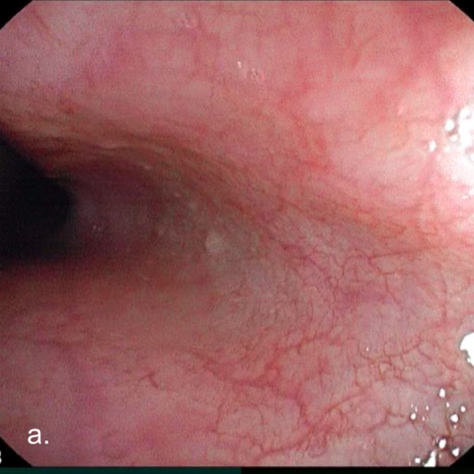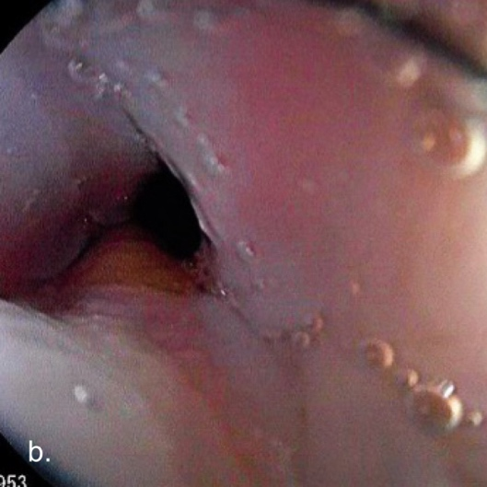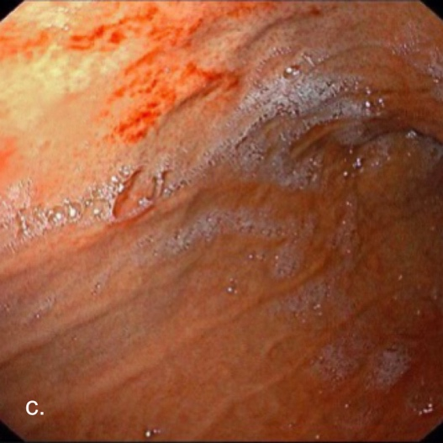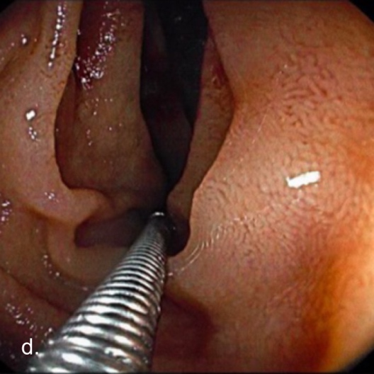

Figure 1. EGD findings: a. candidiasis esophagitis b. mucosal break greater than 5 mm at the LES c. erosions exceeding 30% of the gastric cardia, corpus, antrum d. edematous and hyperemic duodenum

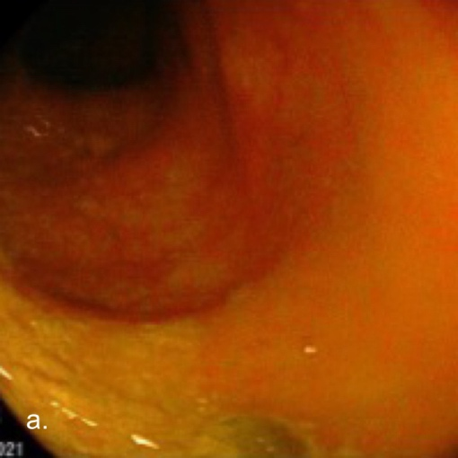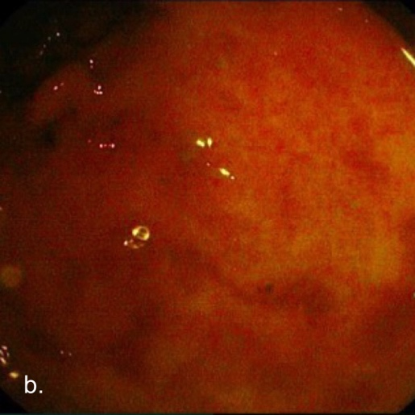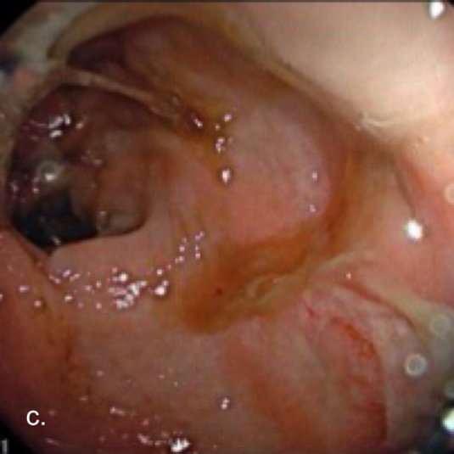
Figure 2. Colonoscopy findings: a,b. edematous, hyperemia, erosions observed in ascending colon c. Presence of mucus, traces of blood, erosive ulcer bleeding in the descending colon
After undergoing the procedures, the patient was treated with sucralfate, esomeprazole, rebamipide, ondansetron, antifungal agent, mesalamine, probiotics, and tranexamic acid. During the treatment, there were no episodes of bloody stools, abdominal pain subsided, and general clinical condition improved. After two days of inpatient care, the patient was discharged and continued with outpatient treatment.
DISCUSSION
In this case, a 29-year-old male with a history of alcohol addiction presenting with melena, hematochezia, anemia, and significant gastrointestinal involvement highlights the complex interplay between chronic alcohol use and bowel disease. Alcohol contributes to GI bleeding through multiple mechanisms. Ethanol metabolism produces acetaldehyde and acetate, compounds that disrupt the intestinal barrier, increasing permeability and systemic inflammation. This disruption facilitates the translocation of endotoxins, exacerbating mucosal damage and promoting inflammatory responses.⁷ Alcohol-induced dysbiosis also alters the gut microbiome, reducing beneficial microbial populations, and allowing overgrowth of pathogenic bacteria. Microbial imbalance further compromises the mucosal barrier and perpetuates inflammation. TThese alterations play a crucial role in the established connection between alcohol-related oxidative stress, increased gut permeability, and the eventual development of alcoholic liver disease and other related conditions. Additionally, ethanol exposure to the small intestine causes malabsorption due to reduced active transport of nutrients across epithelium, such as vitamins, monosaccharides, and several L-amino acids, which could lead to stool abnormality as well.^{7,8}
The presence of erosive gastroduodenitis and esophagitis Grade B in this patient aligns with prior findings that alcohol-induced gastric mucosal damage can lead to significant UGIB. A prospective study by Strate et al. highlighted the role of alcohol in GI bleeding, demonstrating that men consuming more than 30 grams of alcohol daily had a 1.43-fold increased risk of major GI bleeding compared to nondrinkers, with the strongest association observed for upper GI bleeding linked to liquor intake.[5] Alcohol-related GI bleeding often leads to iron deficiency anemia, as observed in this case with a hemoglobin level of 7.5 g/dL. Additionally, the patient presented with hypoalbuminemia (3.41 g/dL) and moderate fatty liver on ultrasound, suggesting early hepatic dysfunction linked to chronic alcohol consumption. Alcohol’s hepatotoxic effects can lead to liver dysfunction, portal hypertension, and the formation of esophageal or gastric varices, significantly increasing the risk of bleeding. In acute settings, alcohol can impair clotting mechanisms and platelet function, exacerbating bleeding tendencies.⁵⁻⁷ However, in this case, we were able to rule out esophageal varices as a likely cause of melena, and the EGD results showed erosive gastroduodenitis instead. As previously mentioned, gastritis is a known mechanism of melena in alcoholism, even in the absence of peptic ulcers.
One of the interesting findings in this patient was the presence of Candida Esophagitis (CE) from EGD. Alcohol impairs intestinal permeability and disrupts the gut microbiota, leading to systemic inflammation and increased susceptibility to infections such as esophageal candidiasis.⁸ Interestingly, alcoholism is known to be one of the major risk factors for CE. Mushi et al in their study stated that alcohol consumption is an independent risk factor for CE (OR 17.1; 4.94-58.87).⁹ In non-HIV patients, around 70% of patients with CE consume alcohol. Study by Chen et al also found that alcohol consumption is an independent risk factor for CE.¹⁰ A case reported by Ali et al. in 2020 also identified CE in a patient with a history of heavy alcohol consumption, presenting with a chief complaint of melena.¹¹ In CE, the most common chief complaint is dysphagia, but other studies have shown that melena along with nausea, abdominal pain, and heartburn are also common complaints in patients.^{12,13} However, in this case, the UGIB was most likely due to erosive gastritis rather than CE, as erosive gastritis is a far more common and established cause of UGIB in in immunocompetent patients.¹⁴ Nevertheless, in immunocompromised patients, CE with ulceration should be considered as a potential source of GI bleeding.¹⁵ The antifungal therapy administered in this case was appropriate according to existing guidelines.¹⁶
A unique finding in this patient was the presence of ulcerative colitis (UC) on colonoscopy with visible erosive ulcer bleeding, with biopsy-confirmed chronic colitis. While UC is primarily an immune-mediated inflammatory condition, alcohol may act as a precipitating or exacerbating factor through dysbiosis, increased intestinal permeability, and direct mucosal toxicity. Alcohol-induced mucosal damage and immune modulation can intensify colonic inflammation, leading to more severe disease manifestations. While alcohol does not directly cause UC, its contribution to symptom exacerbation, disease progression, and relapse is well established.^{16,17} In recent years, this phenomenon could be classified as alcohol-associated bowel disease (ABD), as the diagnosis could be established from the history of alcohol consumption.^{7,18} We mentioned several gut pathophysiological changes due to alcohol consumption in previous paragraphs, which can promote ABD and its development. Although, it is quite tricky to diagnose ABD without considering other possible confounding conditions that cause GI bleeding. However, in this case we were able to exclude several important diseases in this young and relatively healthy patient, such as alcoholic liver disease (with only moderate fatty liver USG presentation), diverticulitis, and hemorrhoid with the help of clinical and supporting examinations (including EGD and colonoscopy). Therefore, the ABD diagnosis could be made.
In terms of management, the patient required acute management focused on hemodynamic stabilization, bleeding control, identifying the source of the bleeding, and addressing potential infections due to presenting with mixed, severe GI bleeding. Pharmacological interventions, including proton pump inhibitors, antifungal agents, and mesalamine, were crucial for managing the identified GI pathologies. The drugs given to this patient were actually guided by the results of EGD and colonoscopy. Hence, both examinations were crucial not only in the diagnostic process, but also in managing the found pathologies. Long-term management included complete cessation of alcohol to prevent further mucosal damage and systemic complications, as further excessive ethanol consumption could worsen the symptoms based on the known pathophysiologies in the future. Additionally, nutritional support and monitoring for potential deficiencies were also vital, considering the malabsorptive potential of alcohol-induced mucosal damage.
CONCLUSION
This case highlighted the profound impact of chronic alcohol consumption on the GI tract, contributing to conditions such as erosive gastroduodenitis, esophagitis, and ulcerative colitis, even in young, otherwise healthy individuals. Alcohol-associated bowel disease manifests across a spectrum, from upper GI bleeding to colonic inflammation, requiring a comprehensive, multidisciplinary management approach. Recognizing alcohol’s role in exacerbating pre-existing GI conditions, along with patient education on the importance of alcohol cessation, is crucial to prevent recurrence and improve long-term outcomes.
REFERENCE
- Saydam SS, Molnar M, Vora P. The global epidemiology of upper and lower gastrointestinal bleeding in the general population: A systematic review. World J Gastrointest Surg. 2023;15(4):723-39.
- Oakland K. Changing epidemiology and etiology of upper and lower gastrointestinal bleeding. Best Pract Res Clin Gastroenterol. 2019;42-43:101610.
- Andersen IB, Jorgensen T, Bonnevie O, Gronbaek M, Sorensen TI (2000) Smoking and alcohol intake as risk factors for bleeding and perforated peptic ulcers: a population-based cohort study. Epidemiology 11: 434–439. pmid:10874551
- Tsochatzis EA, Bosch J, Burroughs AK, et al. Liver cirrhosis. Lancet 2014; 383:1749–61.doi:10.1016/S0140-6736(14)60121-5
- A Prospective Study of Alcohol Consumption and Smoking and the Risk of Major Gastrointestinal Bleeding in Men 2016 https://pmc.ncbi.nlm.nih.gov/articles/PMC5100927/
- Bode C, Bode JC. Alcohol's role in gastrointestinal tract disorders. Alcohol Health Res World. 1997;21(1):76-83. PMID: 15706765; PMCID: PMC6826790.
- Maccioni L, Fu Y, Horsmans Y, Leclercq I, Starkel P, Kunos G, et al. Alcohol-associated bowel disease: new insights into pathogenesis. eGastroenterology. 2023;1(1).
- Engen PA, Green SJ, Voigt RM, Forsyth CB, Keshavarzian A. The Gastrointestinal Microbiome: Alcohol Effects on the Composition of Intestinal Microbiota. Alcohol Res. 2015;37(2):223-36.
- Mushi MF, Ngeta N, Mirambo MM, Mshana SE. Predictors of esophageal candidiasis among patients attending endoscopy unit in a tertiary hospital, Tanzania: a retrospective cross-sectional study. Afr Health Sci. 2018;18(1):66-71.
- Chen YH, Jao TM, Shiue YL, Feng IJ, Hsu PI. Prevalence and risk factors for Candida esophagitis among human immunodeficiency virus-negative individuals. World J Clin Cases. 2022;10(30):10896-905.
- Ali H, Choi S, Jiang Y, Ahmed AM, Damiris K, Ahlawat S. S3422 Candida Esophagitis and Heavy Alcohol Consumption. Official journal of the American College of Gastroenterology | ACG. 2020;115.
- Kimchy AV, Ahmad AI, Tully L, Lester C, Sanghavi K, Jennings JJ. Prevalence and clinical risk factors for esophageal candidiasis in non-human immunodeficiency virus patients: A multicenter retrospective case-control study. World J Gastrointest Endosc. 2023;15(6):480-90.
- Alsomali MI, Arnold MA, Frankel WL, Graham RP, Hart PA, Lam-Himlin DM, Naini BV, Voltaggio L, Arnold CA. Challenges to "Classic" Esophageal Candidiasis: Looks Are Usually Deceiving. Am J Clin Pathol. 2017 Jan 01;147(1):33-42 -> 14
- Koh TK, Wei Jie Lee J, Koh CJ. IDDF2021-ABS-0160 Causes of upper gi bleeding – evaluating the aetiologies in a 10-year retrospective cohort. Gut. 2021;70(Suppl 2):A137.
- Robertson KD, Nagra N, Mehta D. Esophageal Candidiasis. StatPearls. Treasure Island (FL). 2025.
- Pappas PG, Kauffman CA, Andes DR, Clancy CJ, Marr KA, Ostrosky-Zeichner L, et al. Clinical Practice Guideline for the Management of Candidiasis: 2016 Update by the Infectious Diseases Society of America. Clin Infect Dis. 2016;62(4):e1-50.
- White BA, Ramos GP, Kane S. The Impact of Alcohol in Inflammatory Bowel Diseases. Inflamm Bowel Dis. 2022;28(3):466-73.
- Piovezani Ramos G, Kane S. Alcohol Use in Patients With Inflammatory Bowel Disease. Gastroenterol Hepatol (N Y). 2021;17(5):211-25.

